Final Project Documentation: NFL Data

Alisha Moore BDAT 630 1Q 21/FA1

**Dataset Information:**

The dataset that is used for this dashboard is the NFL Play by Play data scrape from Kaggle which details all plays for the NFL from the 2009 to 2016 season. For the purpose of this dashboard I excluded defensive plays and focused only on offensive plays that would contribute to a standard fantasy football league.

**Dashboard Purpose:**

The primary function of the dashboard is to show that Quarterbacks are often over valued in the realm of fantasy football. At the start of any league there is a draft where players select different players to construct a team of various positions depending on league rules. For the purpose of this dashboard I am assuming a one starting quarterback league. Also the dashboard is focusing only on the starting positions for any particular fantasy team.

**Dashboard Function:**

The main aspect of the dashboard is showing the point differences between the top 12 quarterbacks and top 20 receivers and rushers by season. These top numbers were based on a 10-12 team league where only 1 starting quarterback was needed and multiple starters of receivers and rushers. After selecting the first few main starters in a team, the remaining chosen often depends on what other teams pick and is hard to determine what position is better as it would depend on the quality of each player available.

Overall points were determined by totaling points gained by yardage (.1 per yard for running back and receivers and .05 per yard for quarterbacks) and touchdowns (6 points per). Positions were not included in the data so receiver’s category will include all players in the receiver category with receiving yards, or in other words Tight Ends and Wide Receivers are not separated. Interactive Slicer at the top right corner allows the user to pick the Season (year) to view the top points for each position.

Additionally, there is a tooltip report for each position to show details for the points received for any particular player as the data bar is scrolled over.

Conclusion is that in the available data it is more common for the top starting quarterbacks to have similar points over the season than the other positions making it more important to pick a higher tier rusher and receiver than a QB. In other words, there is more value in picking a rusher and/or receiver before a quarterback as you will still be able to get a well performing quarterback after picking the other positions but that may not be the case if a quarterback is picked first in a draft.

**Dashboard View:**

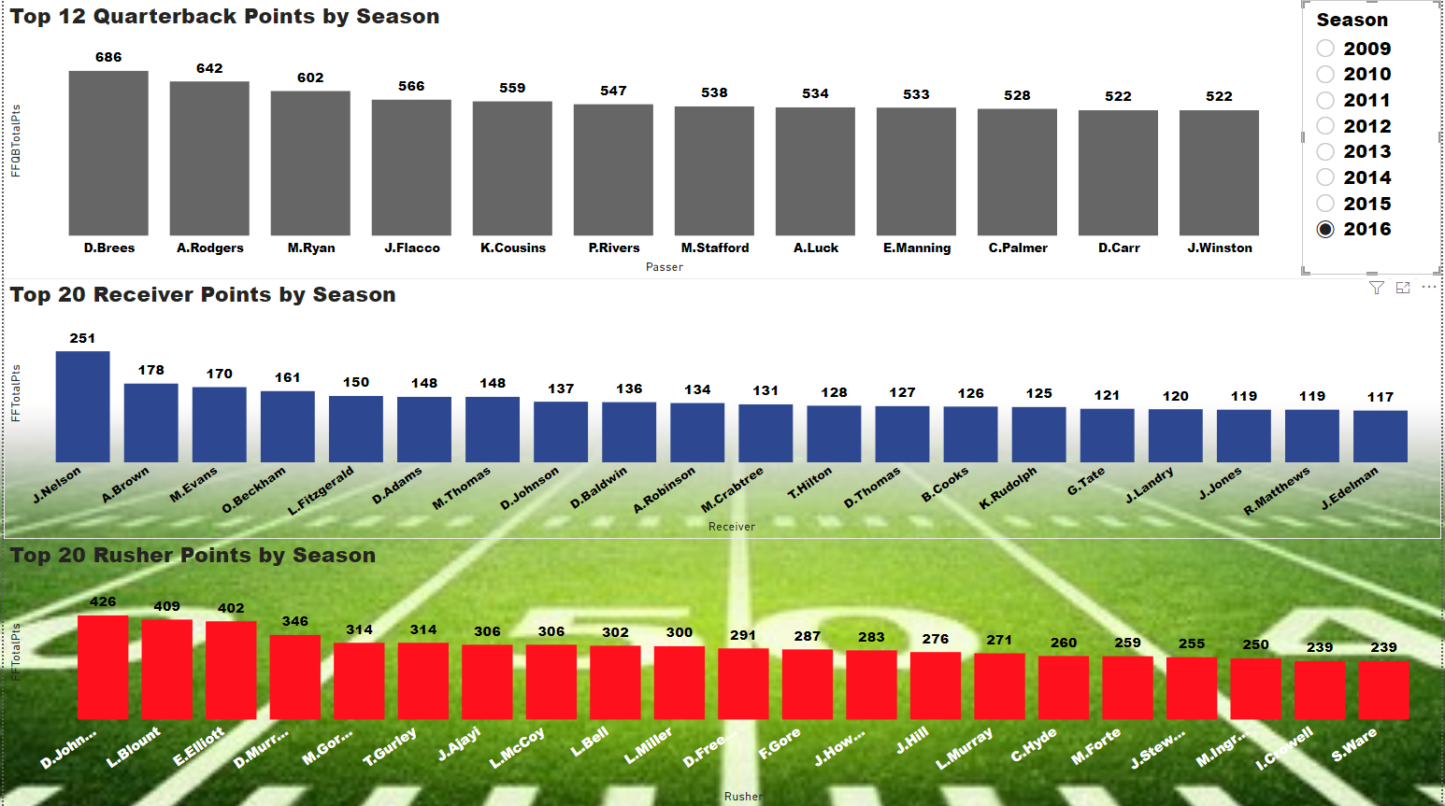

**Interactive Season Selection:**

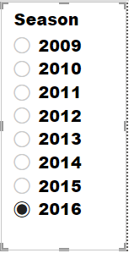

**References**

Horowitz, M. (2018, December 22). *Detailed NFL play-by-play data 2009-2018*. Kaggle. https://www.kaggle.com/maxhorowitz/nflplaybyplay2009to2016.